First announcement of the 16th NAWG Workshop
(Monday, 14th to Friday, 18th October, 2019, Yamagata, Japan)
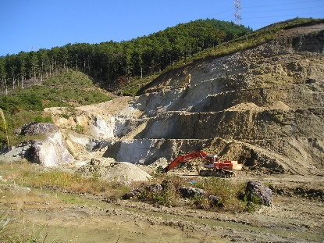 | 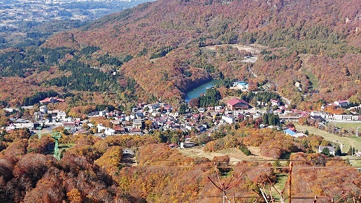
Dobuyama quarry (M.Ito, KIC) | NAWG-16 venue, Hotel Jurin, Zao Onsen
The NAWG-16 workshop will be an opportunity to explore recent developments in the use of natural analogues (NA) in supporting safety cases (SC) for the disposal of radioactive wastes. Argumentation by use of analogy is well established in many fields including philosophy, biology, linguistics and law and most scientists are familiar with this approach and will have used it at some point in their career. If you are keen to learn more, why not come along? Currently, the programme looks like:
Monday, 14th October
Travel to Yamagata, then hotel bus from the airport or station to the Hotel Jurin, Zao Onsen (thermal spring hotel)

Tuesday, 15th October
Session I: Near-field studies, including:
- Analogues of various waste forms
- Canister studies (including a special sub-session on archaeological analogues in Japan)
- Buffer and backfill/plug and seal analogues (including a special sub-session on RWMC’s recently completed Philippines bentonite study)
- Long-term impact of microbial processes
Session II: Poster session

Wednesday, 16th October
Session III: Far-field studies, including
- Radionuclide retardation in the geosphere
Session IV: Recent examples of NA support of the Safety Case
Workshop dinner

Thursday, 17th October
Session V: General topics
- Communication with NA
- What should NA bring to the SC – the view of the regulator
Session VI: Introduction to the International Bentonite Longevity (IBL) project with a description of the Dobuyama bentonite quarry and the Tsukinuno bentonite mine, focus of IBL and the Session VIII field trip
Session VII: examine the influence of geology on the local wine (with wine tasting and vineyard visit) at Asahimachi winery

Friday, 18th October
Session VIII: Field trip to Kunimine Industry Company’s (KIC) bentonite quarry at Dobuyama and outcrops around their bentonite mine at Tsukinuno. Return to Yamagata for onward travel

These are but a few examples and we are open to any suggestions to broaden the scope of the meeting - please drop Russell Alexander (russell@bedrock-geosciences.com) a line with your ideas and comments. Full details, including a reservation form which should be submitted by 26th April, 2019 to reserve one of the limited number of rooms, are available on the NAWG web page (www.natural-analogues.com). Alternatively, to simply join the workshop, please contact Russell before Friday, 4th October, 2019. NAWG-16 will be held with the kind support of NUMO and KIC.
Deadline for extended abstracts is 1st October (NUMO Report) and for full papers is 1st November (Journal Special Issue), more details will be provided on both at a later date.

