First announcement of the 17th NAWG Workshop
(Monday, 8th May to Friday, 12th May, 2023, Zadar, Croatia)

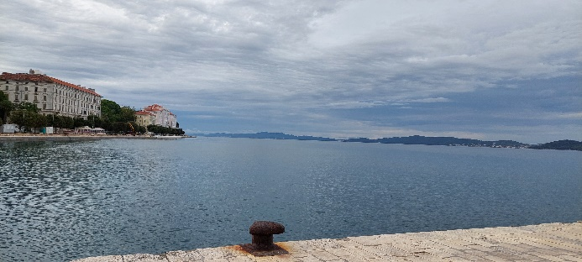 | 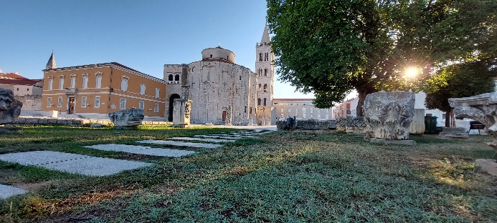
Zadar harbour (image courtesy Galla Uroić) | Zadar old town (image courtesy Galla Uroić)
After several false starts due to the COVID pandemic, the NAWG-17 workshop will finally be held in the historical city of Zadar, Croatia (https://zadar.travel/) and will be an opportunity to explore recent developments in the use of natural analogues in supporting safety cases for the disposal of radioactive waste. Argumentation by use of analogy is well established in many fields including philosophy, biology, linguistics and law and most scientists are familiar with this approach and will have used it at some point in their career. If you are keen to learn more, why not come along? Currently, the aim is to discuss:
Radioactive waste form stability: including vitrified waste stability and spent fuel evolution
Repository near-field studies: including corrosion of copper and steel canisters and the long-term stability of the bentonite buffer.
Repository far-field studies: including self (or regional) analogues of potential repository sites and assessment of potential radionuclide releases to the host rock and biosphere
Stakeholder communication: including examples of approaches used to communicate different aspects of waste disposal to both technical and non-technical audiences
for some 2.5 days, followed by a half-day field trip to local archaeological analogue sites.
These are but a few examples and we are open to any suggestions to broaden the scope of the meeting - please email the NAWG chairman, Russell Alexander (russell@bedrock-geosciences.com), with your ideas and comments. Full details of the workshop (including registration form) are available on the NAWG web page (www.natural-analogues.com).

In addition to making the workshop presentations available online at www.natural-analogues.com shortly after the workshop ends, an online book of abstracts will be produced by the Faculty of Mining, Geology and Petroleum Engineering of the University of Zagreb. All presenters will also be invited to submit a full paper to the journal Rudarsko-geološko-naftni zbornik (The Mining-Geology-Petroleum Engineering Bulletin of Croatia).

To participate in the workshop, please email your registration form to Russell (russell@bedrock-geosciences.com) by Friday, 17th March, 2023.

