Registration form for the NAWG-17 workshop

Monday, 8th May to Friday, 12th May, 2023, Hotel Kolovare, Zadar, Croatia
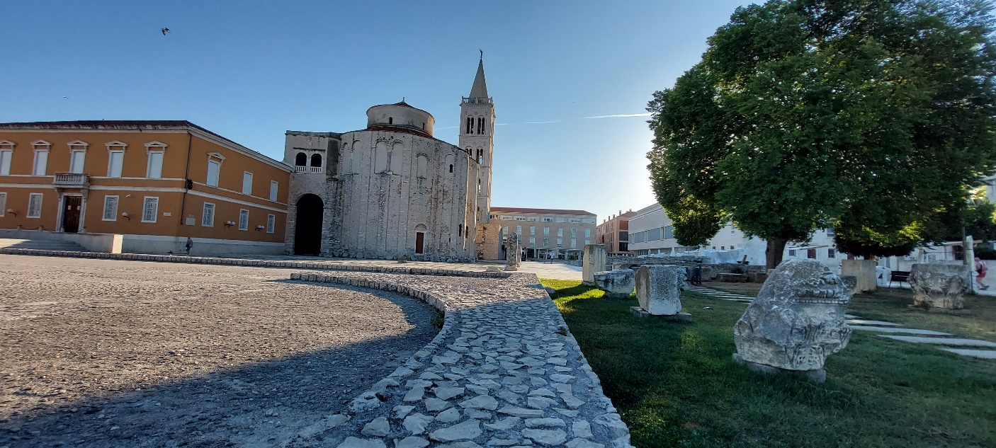
Zadar old town (image courtesy Galla Uroić)
Please submit to the NAWG chairman, Russell Alexander (russell@bedrock-geosciences.com), by Friday, 17th March, 2023 (with confirmation of payment by Thursday 23rd March, 2023).
There is no charge for workshop participation, but we have arranged a package deal for €850 per person which covers:
- 8th (Monday) to 12th (Friday) May: 4 nights in a single room including breakfast
- 8th May: ice-breaker at the hotel pool in the evening with finger-food and local wine
- 9th to 11th May: use of meeting room and associated facilities
- 9th to 11th May: lunch in the hotel along with coffee breaks (with biscuits and cake) morning and afternoon
- 9th May: dinner in the hotel
- 11th May: workshop dinner in a local restaurant
- 11th May: all costs for the afternoon excursion (NB packed lunch will be provided)
Payment details are noted below.
If you wish to attend only part of the workshop or to bring a non-participating friend, you/they are also most welcome. But please let us know so we can arrange lunches etc. for the time you/they are present.
Would you be so kind as to let us know:
- Your name:
- Institution/company:
- Email address:
- If you would like to submit a paper/poster:
- If so, title of paper/poster:
- Field excursion (please just add ‘yes’ if you wish to participate):
- Any dietary preferences (yes/no, please add details if yes):
Workshop payment details:
Please pay by direct bank transfer (and include all transfer costs please) to:
Bedrock Geosciences, Schwyzergraben 1, 5105 Auenstein, Switzerland. Registered in Switzerland, CHE-113.627.121
Aargauische Kantonalbank, 5103 Wildegg, Switzerland. IBAN CH26 0076 1644 9555 8200 3, BIC KBAGCH22, account number 6449.5558.2003
Additional information:
Field excursion

We plan a half-day excursion to two archaeological analogue sites in the Murter area (about 1 hour south of Zadar). Travel to the sites will be by coach (packed lunch provided) and hiking boots are recommended (rough ground and snakes). In addition, one site requires swimming costumes and snorkels to appreciate it in it’s full glory.

Publications
In addition to making the workshop presentations available online at www.natural-analogues.com shortly after the workshop ends, an online book of abstracts will be produced by the Faculty of Mining, Geology and Petroleum Engineering of the University of Zagreb. All presenters will also be invited to submit a full paper to the journal Rudarsko-geološko-naftni zbornik (The Mining-Geology-Petroleum Engineering Bulletin of Croatia).

Transport to Zadar

There are many direct international flights to Zadar airport (please see https://www.zadar-airport.hr/ for details) or Croatia Airlines flies domestically several times a day to Zadar from Zagreb airport (see www.croatiaairlines.com for details). Alternatively, it is possible to travel from Zagreb airport to Zadar in 3 hours or so by hire car or in 5-6 hours by bus.

Transport to the hotel from the airport is possible by bus (to the city centre with a limited timetable, meaning queues are normal at most times) or taxi, but we would suggest using Taxi Lulic (+385 23 494 492 airport desk or +385 23 242 224 city office, email info@lulic.hr). It is also possible to travel to Zadar by direct ferry from Ancona in Italy (see www.netferry.com for details).

Historical Zadar

Zadar is a beautiful city which is described on the Zadar tourist information website (https://zadar.travel/) as “…both an atmospheric time machine and an open-air museum.” and it is well worth getting to know this lovely area of the Croatian coast.

If you wish to extend your stay in the hotel, either before or after the workshop, please let us know and we can arrange it on your behalf.

Please let us know if you prefer sharing a double room (at a reduction of €150 per person).

